CSCE2114 Digital Design

Lab 3 – Part 2

During this lab you will construct a single circuit and document its operation. The ICs available are the 7400, 7402, 7404, 7408, 7410, 7411, 7427, and the 7432 (the problem statement may also restrict what chips you may use). You will construct each design using the PB-505 trainer. The lab problem statement as well as a diagram of each IC is shown below.

1. F(A,B,C) = m(0,3,7): Implement F’ of by using only NOR gates (converted from standard POS form). (**NOTE: it is F’ not F**)

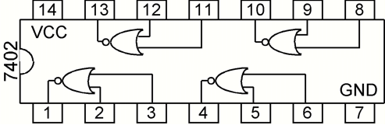

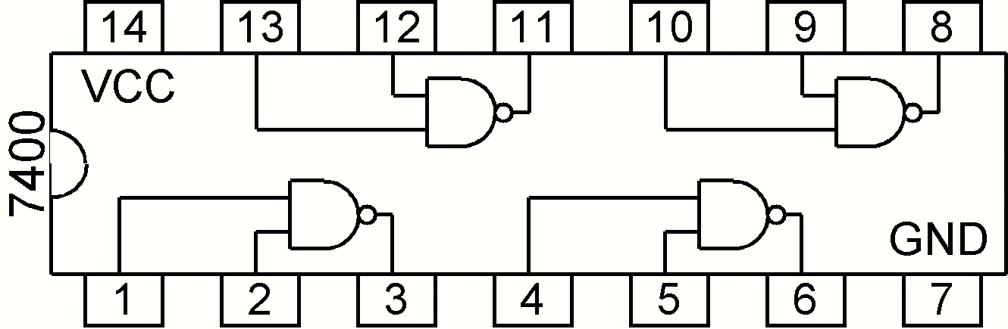

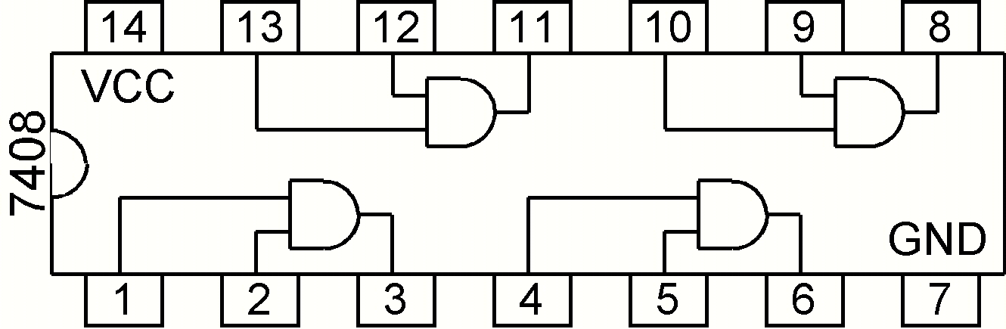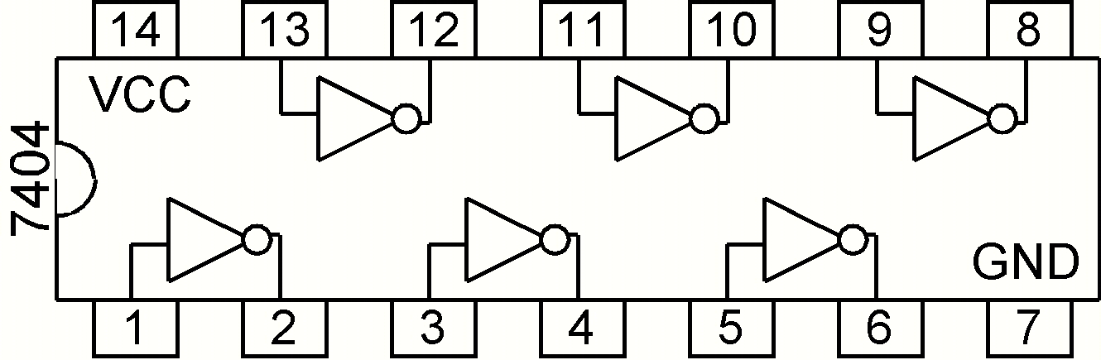

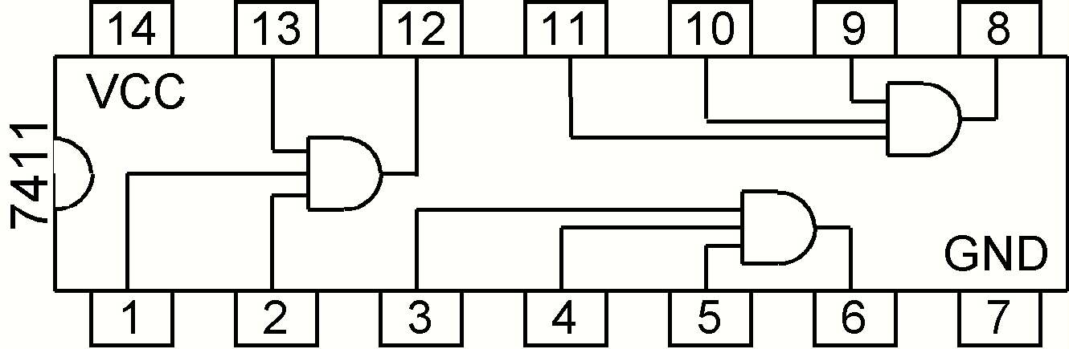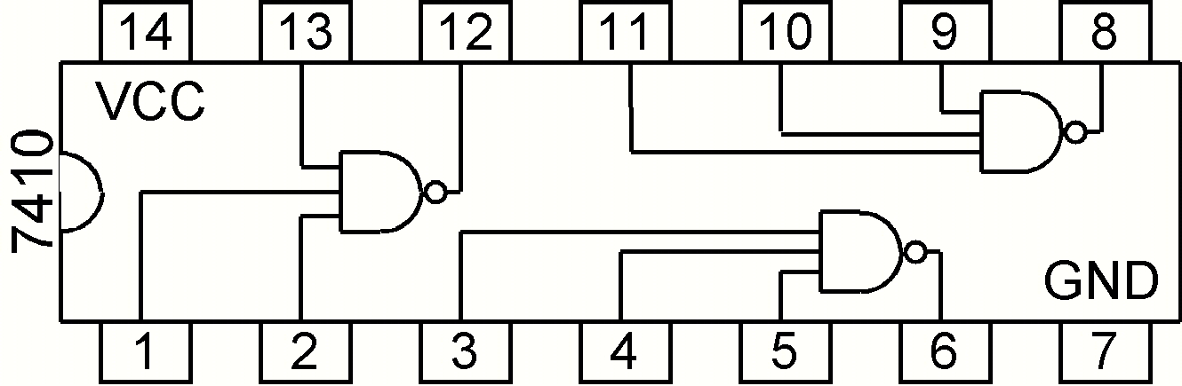

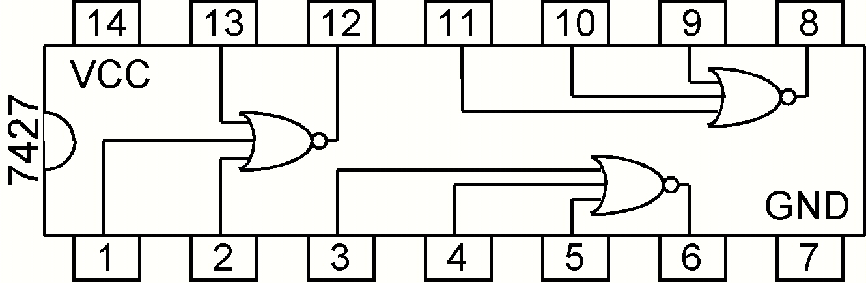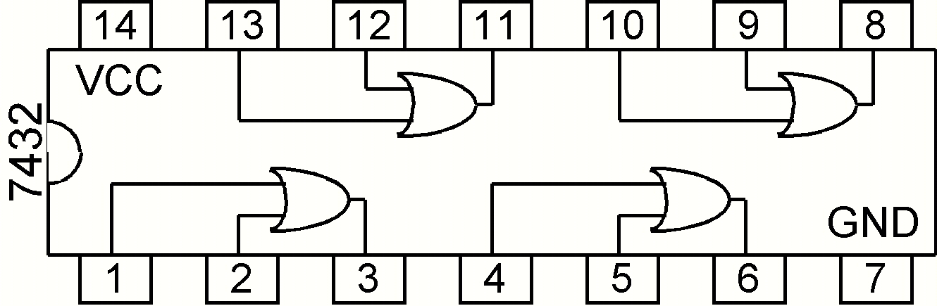

1) First write out a truth table for F’ as well as its equation in standard **POS** form. Next you should draw the circuit for F’ using only NOR gates (it may be helpful to first draw the circuit using AND gates and OR gates), and then implement it on the breadboard. Be sure to show your TA your completed circuit.

Please refer back to Lab 1 if you need any reminders on how to use the trainer board or the 7400-series ICs. The inputs of your circuit should be connected to the switches on the bottom left, and the output should go to the LEDs on the top right. Remember to only connect the chips to the +5V and GND connections.

You should include the POS equation of F' along with any schematic drawings of the circuit in your report.